Create one IAM user and assign EC2 and S3 full access roles

i will be creating a new iam user in aws and giving full ec2 access and s3 full access for the user
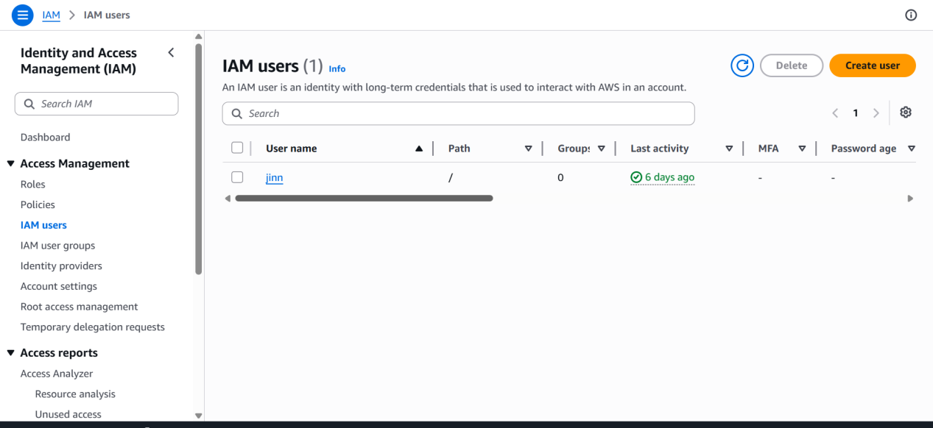

Now in we need to create a new user and add policy that has full ec2 and s3 access

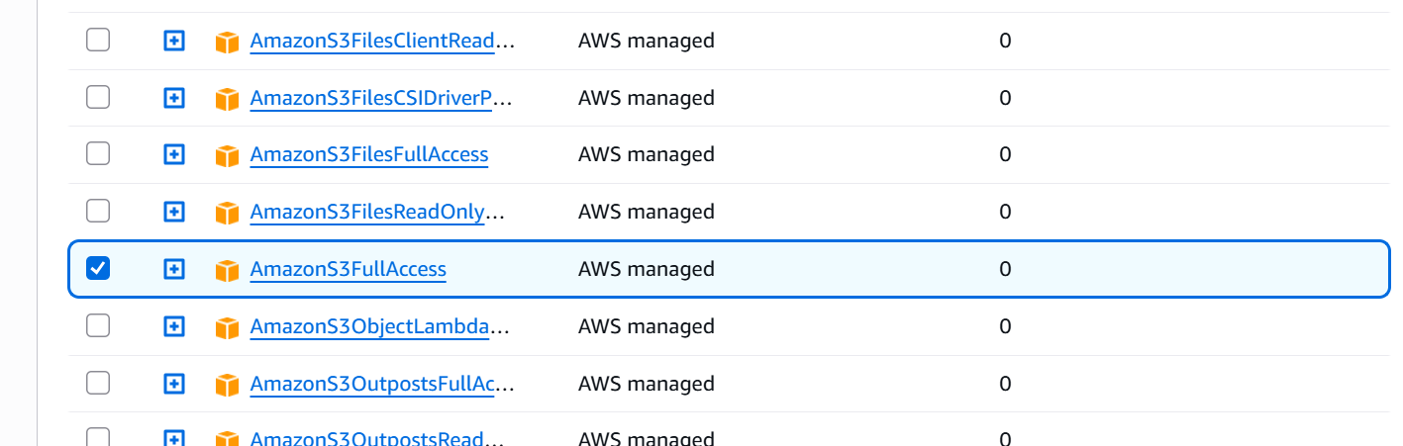

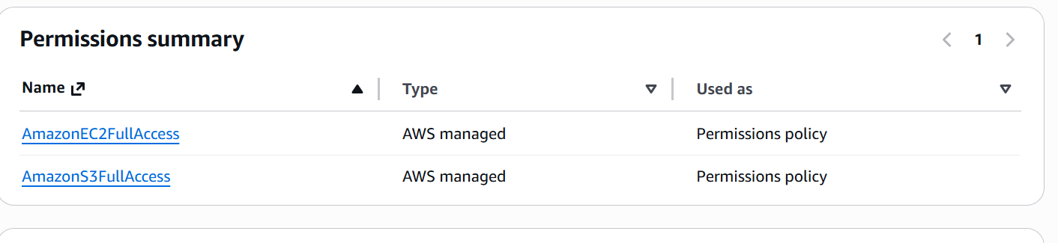

Now new user with full access for ec2 and s3 has been created
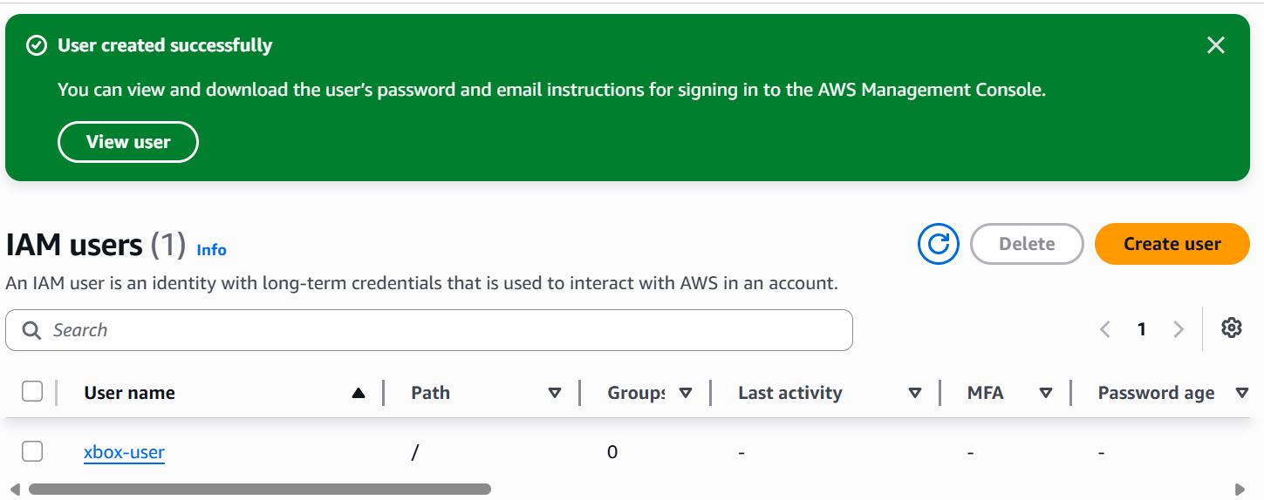

Create one group in IAM and assign read access for EC2

Creating a new group
And giving only ec2 read access for the group
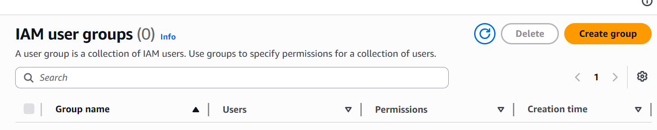

Click on create group
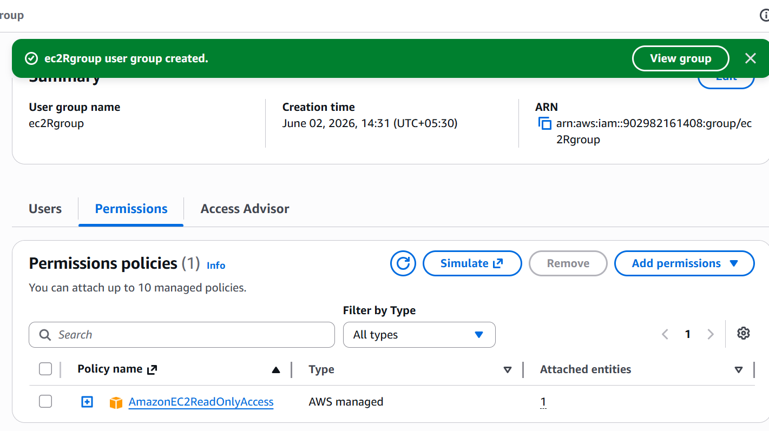
Here I have created a goup and gave only read access for the new group

Create a new user named "Devops" and add to the group created in task 2

I will be creating anew user without any permissions and adding that user to the above group that has only ec2 read access

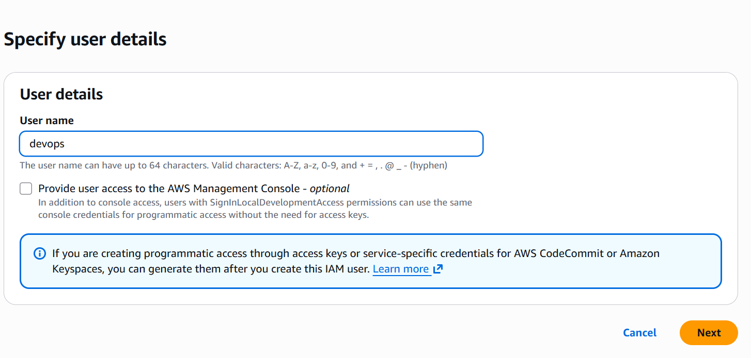
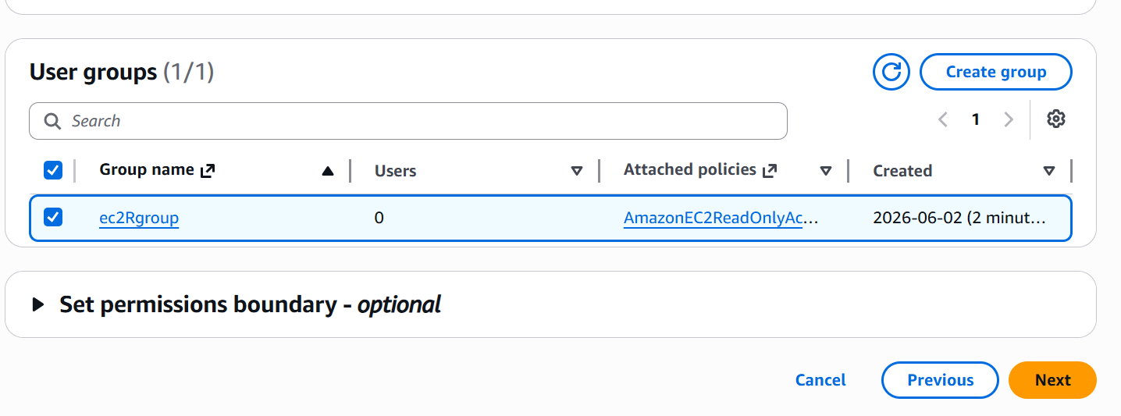

Here I have added the user to the previously created group while creating a new user only

Write a bash script to create an IAM user with VPC full access

First we need to configure aws accesskey to local machine I have used git bash for it

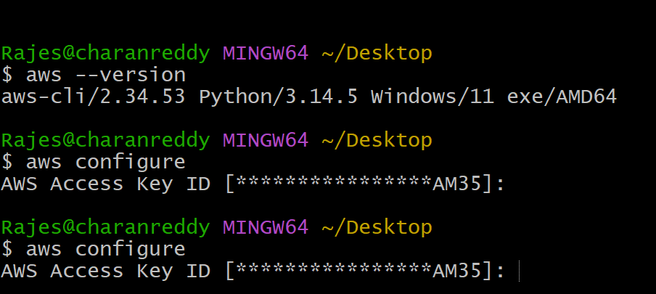

I have successfully configured my access key to aws cli in git bash locally

Next I will be using a bash script
To create a new iam user and give full vpc access to the user
Here I have created a new textfile and written bashscript
That it has to create a new user and and should give full vpc access and it should create an accesskey for the user
Here in script we need to give policy arn number

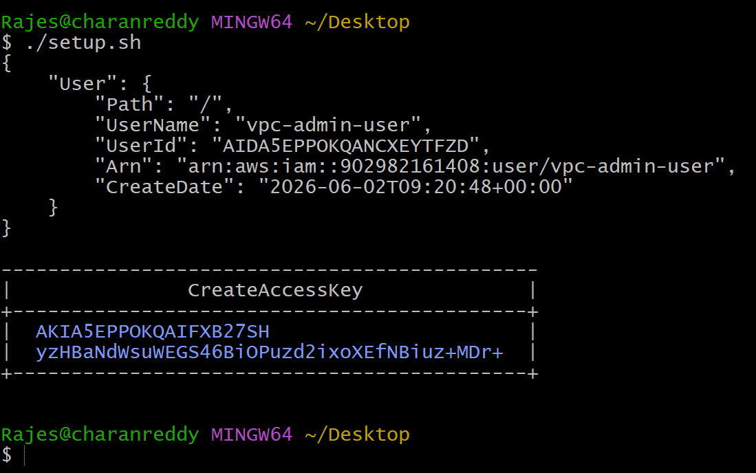

As we can see new user has been created
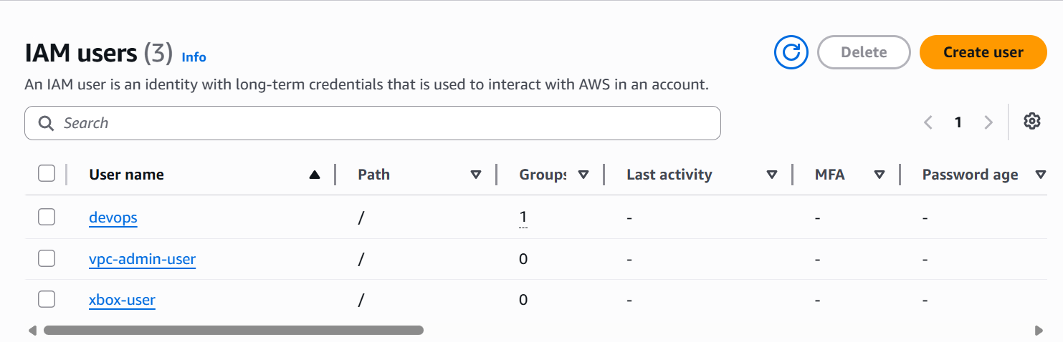

Create an IAM policy to allow EC2 access for a specific user in specific regions only

I am creating a new policy for a particular user for ec2 access
In a particular region

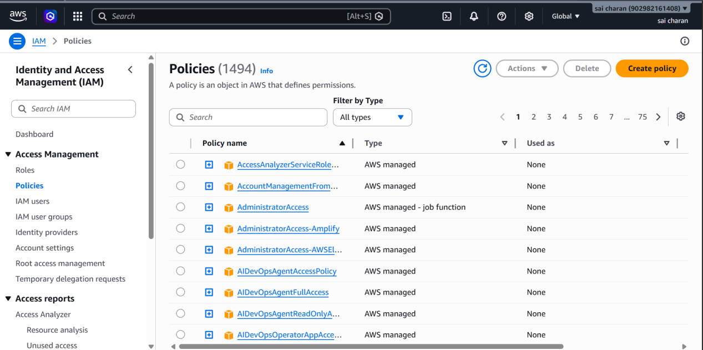

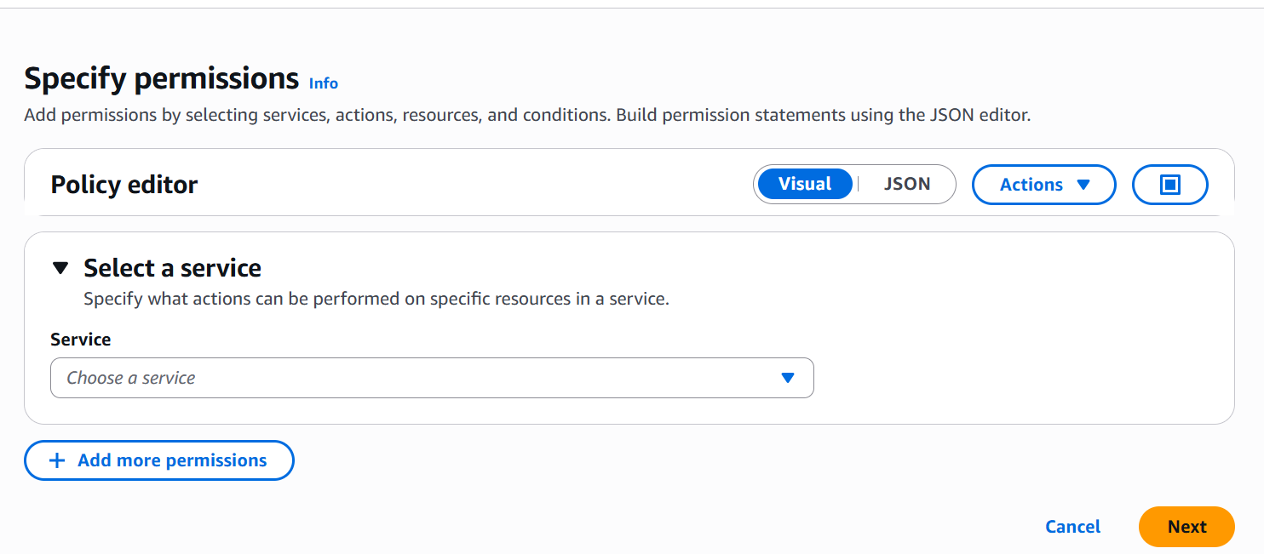
Now below ss shows that which permission should be given for ec2 iam giving all ec2 actions

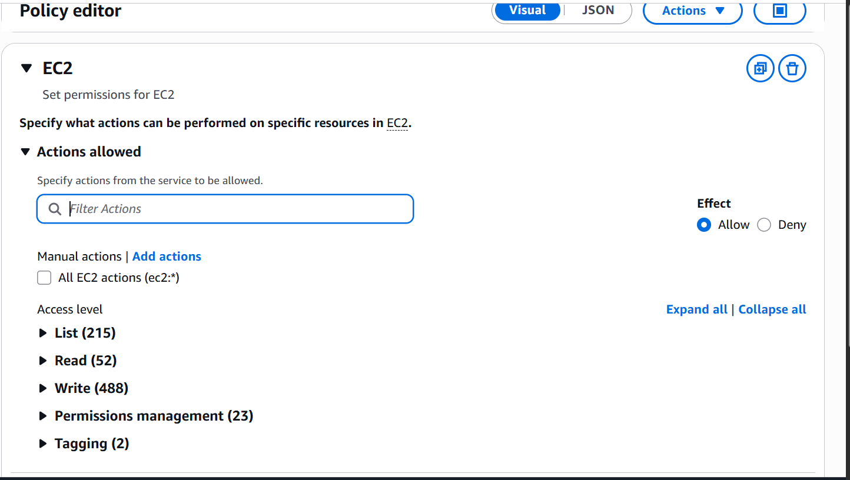

Here I have mentioned us-west-1 for the region the user in this region only can access to the policy that I have mentioned

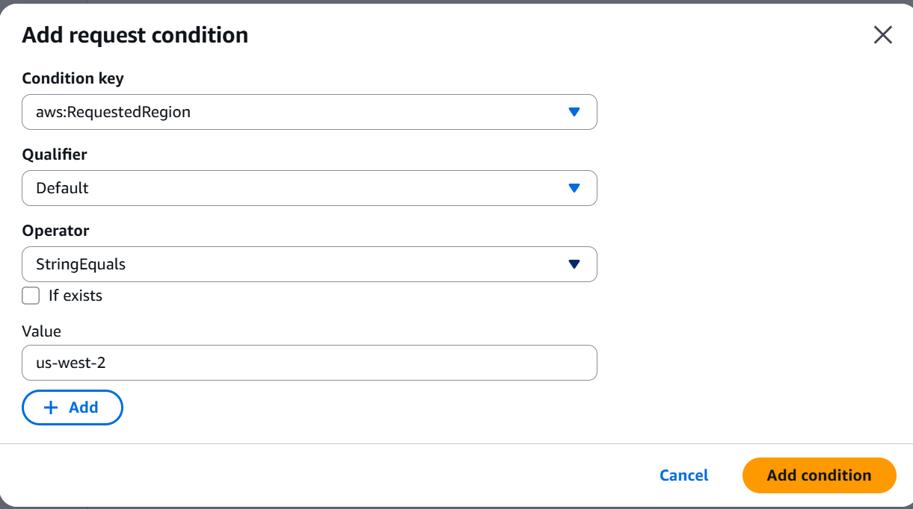

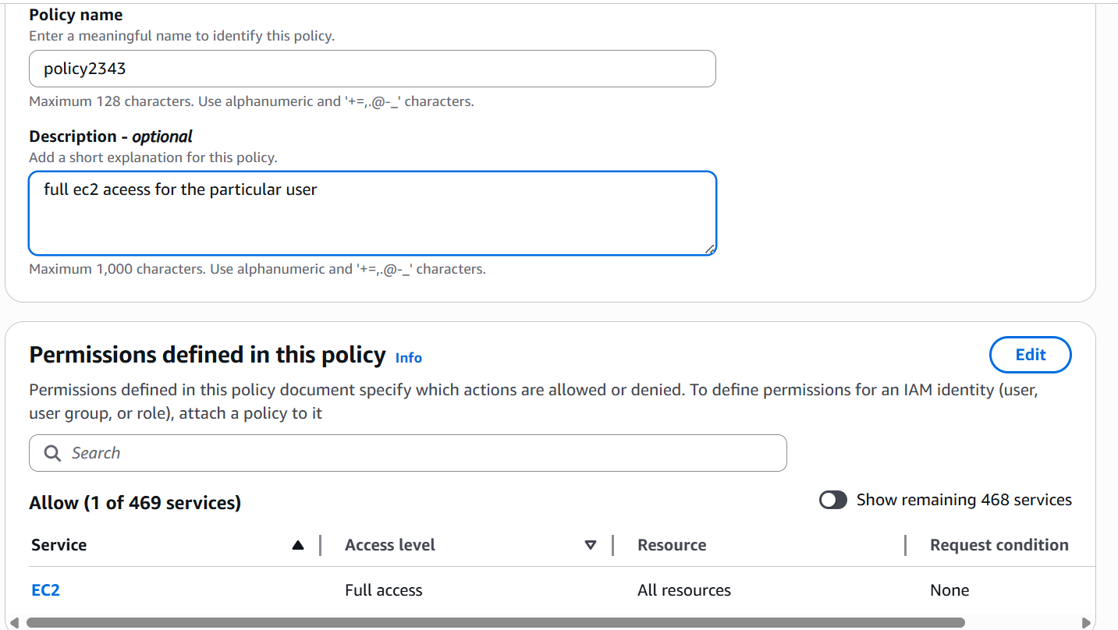

Here I have attached the new policy to already existing user 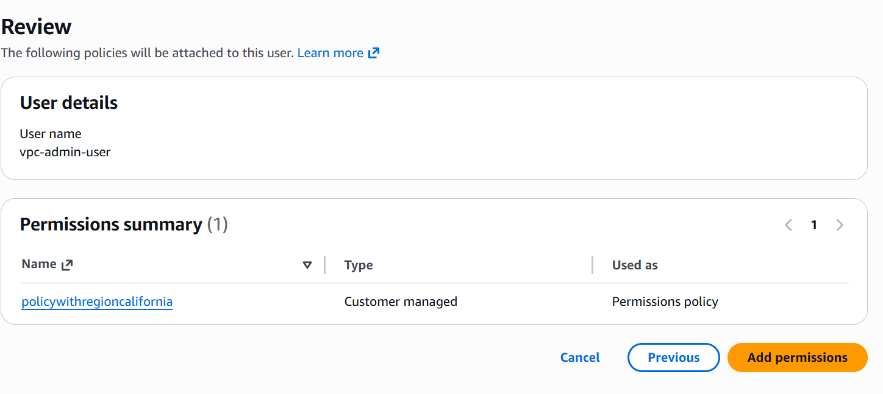

Here we can see that this user has only ec2 access and remaining as API ERRORS

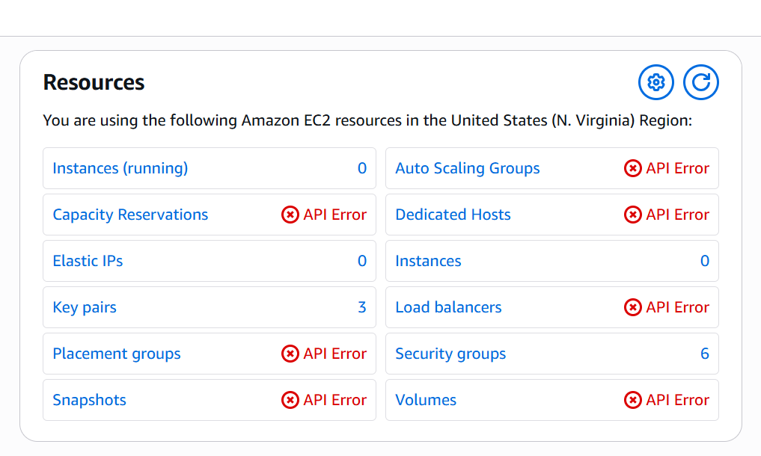

Creating a role for s3 access for 2 different aws accounts 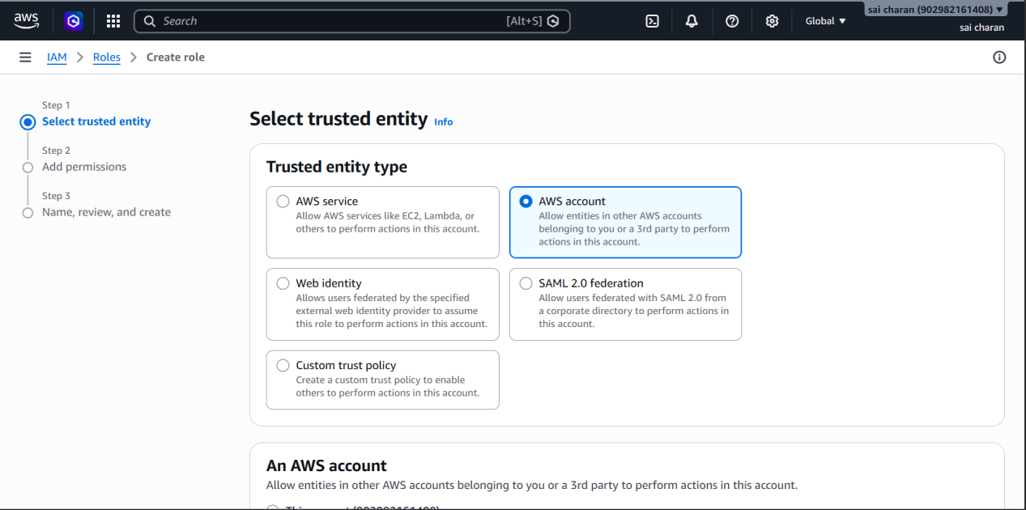

New role has been created

Adding inline policy for the newly created role for cross account s3 access

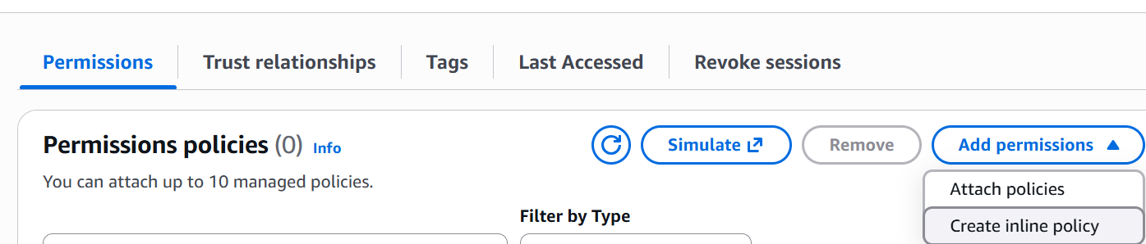\

Giving permissions for list of my buckets

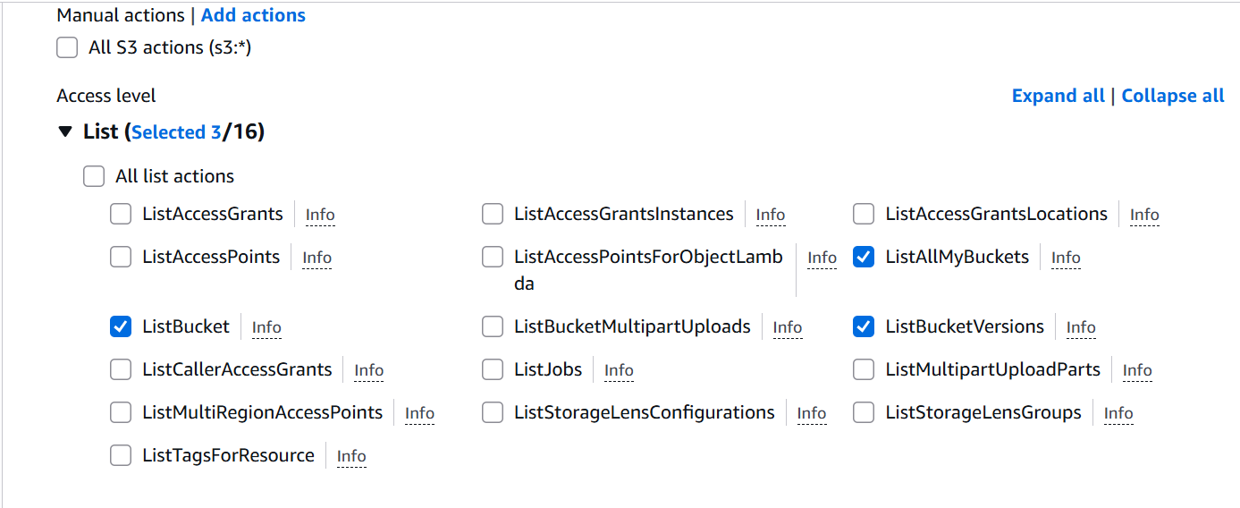

Here I have used different method
I have used other account cannonical id to give access to my s3 bucket
In my s3 bucket I changed permissions and allowed acl and public access

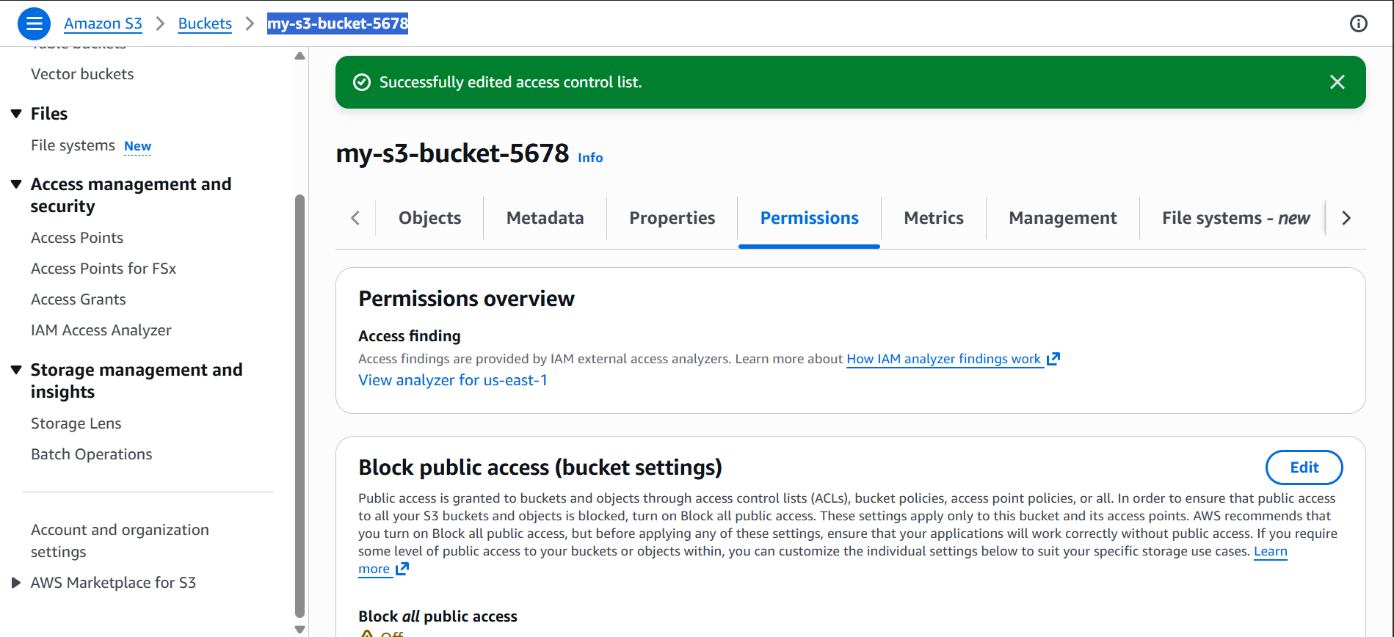

In ACL I have given to other user only read and list access to my s3 bucket

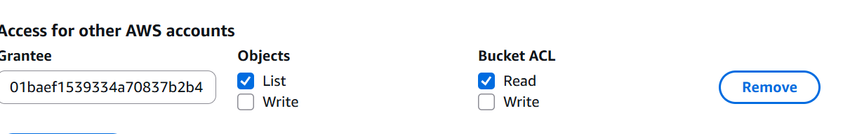

Now the other user can llist my s3 bucket from his aws cli

